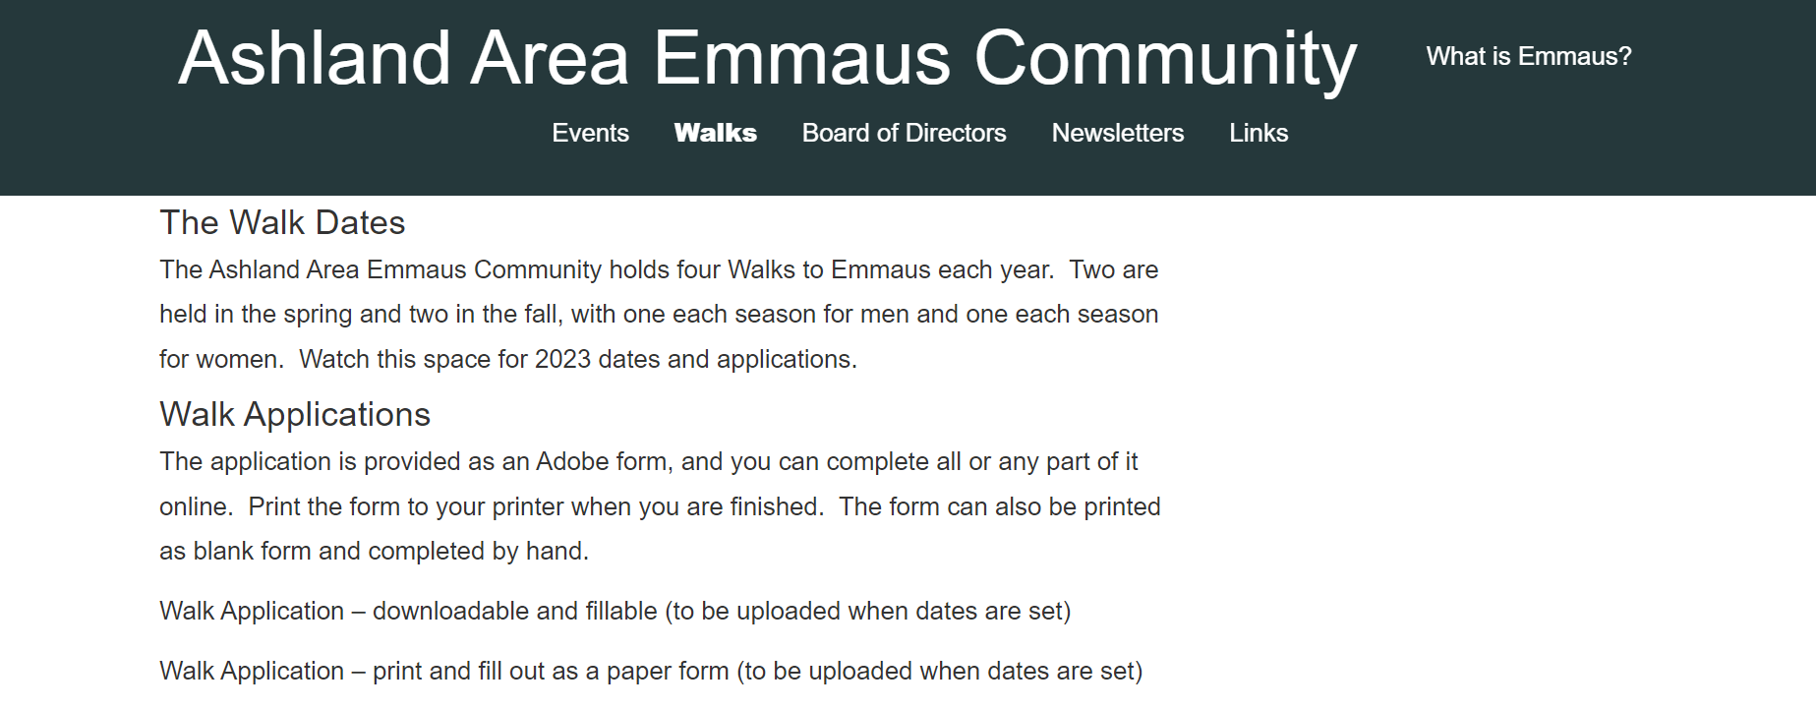

For more information, click on link below:
https://ashlandemmaus.com/ashland-area-emmaus-community/walks-2/

